|  |  |
| --- | --- |
| Assessment Title | Assessment 2 – Innovate Solution |

## Competency Details

|  |  |
| --- | --- |
| Unit code/s and title/s | BSBCRT512 - Originate and develop concepts |
| Qualification code/s and title/s | ICT50220 Diploma of Information Technology |
| Business unit/Work group | Business & Arts / IT Studies |

## Instructions

|  |  |
| --- | --- |
| Method/s of assessment | Observation (Collaboration) Written (Questioning) |
| Overview of assessment | In this assessment you will research current best practices for the issue you have chosen to provide a solution for within the scope of the project which you completed in Assessment 1. You will also complete a cost benefit analysis for the issue chosen. You will brainstorm with another student who is working on the same issue and finalise a checklist to use for your development of the concept of a solution in Assessment 3 – Refine and Implement. |
| Task/s to be assessed | In this assessment you will complete the following tasks:   * Task 1 – Brainstorm Concepts * Task 2 - Evaluate viability – Cost benefit analysis * Task 3 – Research best practice |
| Time allowed | The submission dates for each assessment are provided in the Study Schedule in the **Home** section in Learn |
| Location of assessment | Assessment can be completed anywhere with access to the resources required. Task 1 – Brainstorm Concepts needs to be completed in a classroom, a Virtual Classroom or via Teams for external students. |
| Decision making rules | To receive a satisfactory outcome for this assessment you must complete all parts correctly. Word Counts are provided as a guide only |
| Assessment conditions | Skills in this unit must be demonstrated in a workplace or simulated environment where the conditions are typical of those in a working environment in this industry. This includes access to:   * Background information required to evaluate the operational factors that will affect the implementation of concepts. * Opportunities to collaborate with others throughout the concept development process. * Task 1 – Brainstorm Concepts is an observable assessment * Tasks 2 & 3 are unsupervised assessments, and you may access any required resources. |
| Resources required | * Microsoft Word * Internet connection for online research * BSBCRT512 – ASDS – Originate and Develop Concepts Scenario.pdf * BSBCRT512 – ASDS –ITWorks Injury Reporting.pdf * BSBCRT512 – ASDS – ITWorks ICT Support Complaints.pdf |
| Result notification and reassessment information | You will be provided feedback and the result for your assignment on TAFESA Learn. You will be and given the chance to resubmit with required corrections only once.  Refer to the TAFE SA [Assessment Policy](https://students.tafesa.edu.au/docs/default-source/apply_enrol/assessment-policy.pdf?sfvrsn=112c415_16) for more information |

# Task 1: Brainstorm concepts

In this task you will collaborate and brainstorm your ideas for an interface concept design for the issue you have chosen to provide a solution for, with another student. Your Lecturer will assess this by observing you performing the task. You will need to brainstorm with one other student who is also working on a solution for the same issue. You may be able to arrange to meet with another student yourself or contact your Lecturer who will organise another student to work with you. You need to both actively facilitate respectful and effective interaction to influence your colleague to have joint directions so that you both have the same measurable actions at the end of the meeting. You will play an active role in facilitating effective communication in you group. You may add further actions as you both agree and brainstorm innovative ideas.

Create a checklist that lists all the measurable actions that you will incorporate into your interface design for the issue you have chosen to work with. Refer to the agreed measurable actions from your Assessment 1.

Contact your Lecturer when you are ready for this meeting. Your Lecturer will need to observe this meeting taking place. You can either do this meeting in class, over a Teams meeting or via audio recording with another student. (You will need to submit the audio recording if done outside of class, no longer than 5 minutes). Upload to your TAFE SA OneDrive and share the link with your Lecturer.

Document your discussion under the headings below:

* Name of student you met with.
  + Amos Chamberlain, 001174912
* Date of Meeting.
  + 26/05/2023
* Observing Lecturer Name.
  + Deb
* Summarise discussion in approximately 50 words.
  + We had discussed the minimum measurable actions and had come up with points for each of us to add into our applications, Amos is making a java applet with each actions, I’m making an Android application with an action page for each measurable action.

Update your checklist with added ideas from your brainstorming session (The checklist will need to be submitted along with this assessment containing your written answers).

1) Training and Information on slips and trip hazards.

* + - Information on what is a slip hazard.
    - Procedure to eliminate slip risks, e.g., mop up all spills when seen.
    - Information on what is a trip hazard.
    - Procedure to eliminate risk, e.g., no extension cords across walkways.

2) Training and Information on office hazards

* Identification of common office hazards, such as faulty electrical equipment or improper storage of heavy objects.
* Procedures for reporting and addressing office hazards promptly.
* Training employees on how to correctly handle office equipment such as printers or paper guillotines

3) Training and Information on manual handling and lifting.

* Techniques for proper manual handling and lifting to minimize the risk of injuries.
* Education on the importance of using mechanical aids, such as dollies or forklifts, for heavy lifting tasks.

4) Training and Information on office ergonomics

* Guidelines for setting up ergonomic workstations to promote good posture and reduce the risk of musculoskeletal disorders.
* Information on adjusting chairs, desks, and computer monitors for optimal comfort and productivity.

5) Training and Information on reaching above head height.

* Awareness of potential hazards and risks associated with reaching above head height
* Techniques for safely reaching above head height, including the use of step stools or ladders when necessary

# Task 2 – Evaluate Viability – Cost benefit analysis

You are paid on a fortnightly basis of $2800 gross. The project is going to take 7 weeks for you to complete the concept design. A programmer is paid the same amount as you and they will need 4 weeks to fully develop and automate your design.

The cost to ITWorks for a solution for the ITWorks Support Complaints is $15,400.

The Manager came and spoke to you and is debating about whether he can afford to have two employees work on this project for the next 11 weeks. Other employees are going to need to cover your current roles and he is considering whether it would have been better to buy a software proprietary solution. One of his friends in another company recommended Vivantio Help Desk software. The Manager has asked you to price it and let him know if it would be more cost effective than his employees’ wages. He wants to know how much Vivantio would outlay him over a five-year period. There are 6 ICT Support staff who will be using the software if he bought it.

The Manager is particularly interested in reducing customer wait time, custom dashboards and managing workflows. For costing of the software, go to the website:

<https://www.vivantio.com/pricing/>

Q1) How much would Vivantio cost over a five-year period for 6 ICT Support staff to access? Answer the questions below to show your calculations:

* Which Vivantio edition have you chosen?
  + Vital
* How much is this edition per month per user?
  + $52
* How much would it cost ITWorks per month?
  + $312
* How much would it cost ITWorks for the first five years?
  + $18,720

Q2) Which is the more cost-effective solution? Vivantio or internally developed solution?

It is more cost effective to build it in house

Q3) If the internal development costs $15,400, then for the issue ITWorks injuries what would be the cost benefit if there are no further injuries for the next year?

If there are no injuries in the next year an estimated $612.5 will be saved if an internal app is developed

**In your ITWorks Project Plan completed in Assessment 1, summarise all the above information you have gathered for your answers under the heading - 2. Cost Benefit Analysis.** Your Project Plan will need to be submitted with this completed assessment on Learn.

# Task 3 – Research best practice

For the issue you have chosen to work with in Assessment 1, you will now research best practice examples of similar products. You do not need to buy or access actual software, but you will need to research and compare the best features of the products for a similar solution and one that you can implement in your design.

For each bullet point no more than 15 words each are required. List any URL’s if you accessed any in your research as references below your written answers.

Choose your issue below and delete the other one before completing your answers. An example of features has been provided for each issue; you will need to provide 3 more.

Issues: ITWorks Injury Issues

*Example: Provide an infographic that demonstrates a correct ergonomic workstation setup.*

* 1. Be seated with your back straight, or be standing

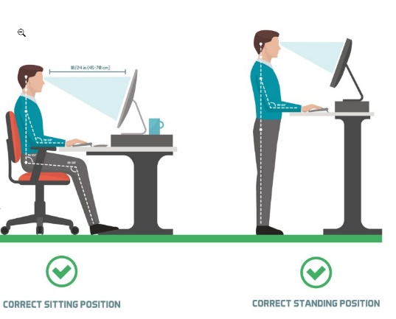

[healthandbalance.com.au](https://healthandbalance.com.au/workstation-desk-posture-ergonomics/)

* 1. have the monitor at eye level

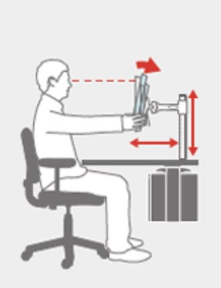

[loctek.us](http://loctek.us/how-to-create-an-ergonomic-workstation/)

* 1. keep arms at a right angle

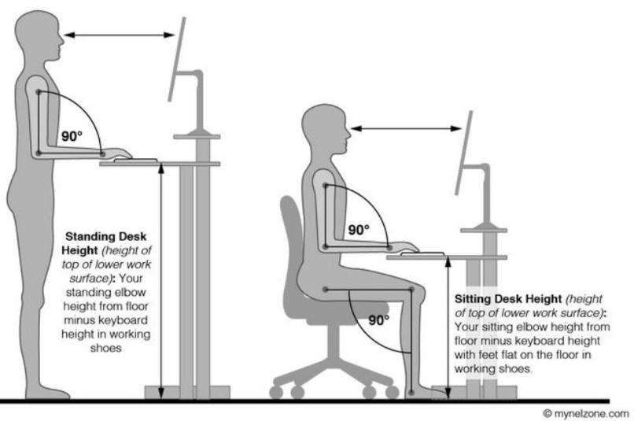

mynelzone.com

* 1. use an ergonomic mouse and keyboard

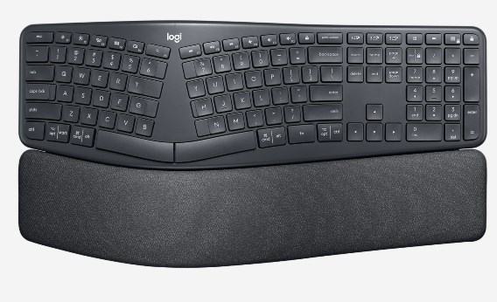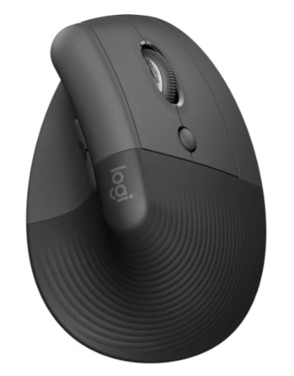

logitech.com

5) Take regular breaks to move around and get blood flowing.